ABHISHEK YADAV
EMP.ID-16915
Security Management System

Background:
The bank wants to develop a new corporate banking for payment system. The new system will serve the corporate customers of the bank and allow them to make payment transaction. The application will be accessed by the customer's used on the internet. The bank needs a robust security module for the application. Below given are the specification for the security sub-system to be developed for the bank.

The security subsystem will have following features
- Customer Master
- Department Master
- User Master
- Login Process

Customer – Is the company or the organization who is serviced by the bank. For example Nucleus Software Exports Limited is a customer of HDFC bank and HDFC bank provides services to nucleus software. A customer will have following attributes
- Customer Id
- Customer Name
- Address line 1
- Address line 2
- Pin code
- Phone Number
- Contact Person Name
- Relation ship manager name
- Maximum Transaction Amount

Department Master– Customer's company is divided into various department performing different function. For example finance department is responsible for account and finance of the company, product management department is responsible for development of a new product. A company can have multiple groups, the system should have provision for creating multiple groups.
Group will be identified by following:
    - Department Id
    - Department Code
    - Department Name

User Master– A User is the end user of the system, a user works in a department and at a time a user can work in only one department. The user will login into the system and based on the role assigned, the user will be able to able to access the functionality of the system
A user will be identified by following
- User Id
- User Code – to be used as user login id
- User Name
- Contact Number
- User e-mail id

A user have one of the following roles :
- Maker – The user can perform only user action such as Addition, Modification, Deletion, ad Search of record
- Checker – Checker user can perform only search, authorize or reject the record.
- Maker-Checker – The type of user can have rights for both maker and checker action.

Login Process - The user should be able to login into the system using a user id and password.
Following points should be taken care of
- Each user will be assigned a unique used id and password. The password will be saved in the database in encrypted form.
- The system must provide a provision for restricting the login of the user on specific days. For example a user A can access the system only on weekdays and should not be allowed to login into the system on Saturday and Sunday.
- After n (number maintained in system parameter table) un-successful attempts the user should not be marked in the system

System Parameter – The System shall maintain a list of system parameter in a database table which will be used in the system for further processing. The table will be populated using setup scripts.

- Following parameters should be maintained in the system
  - Rejection Level
  - Unsuccessful login attempt – This will be used at the time of login into the system. For example if the number of un-successful attempts is more than the number defined in this table then the user will be locked in the system.
  - File location – location of the file from where the file will be picked up from the local folder for upload

Following details should be maintained for all the records saved in the database:
- Maker Id- Id of the user who created the record
- Maker Date – The date on which the record was created
- Checker Id – the Id of the user who authorized the record
- Checker Date – The date on which the record was authorized by the user
- Record Status – the status of the record

Develop following for the system
- Identify the entities and relations between the entities – Day 3,4
Ans:-
Entities:
1.CUSTOMER
2.DEPARTMENT
3.USER
4.MAKER
5.CHECKER
6.MAKER_CHECKER
7.LOGIN_PROCESS
8.SYSTEM
9.FINANCE_DEPT
10.PRODUCT_DEPT
- Draw ER diagram.– Day 3,4
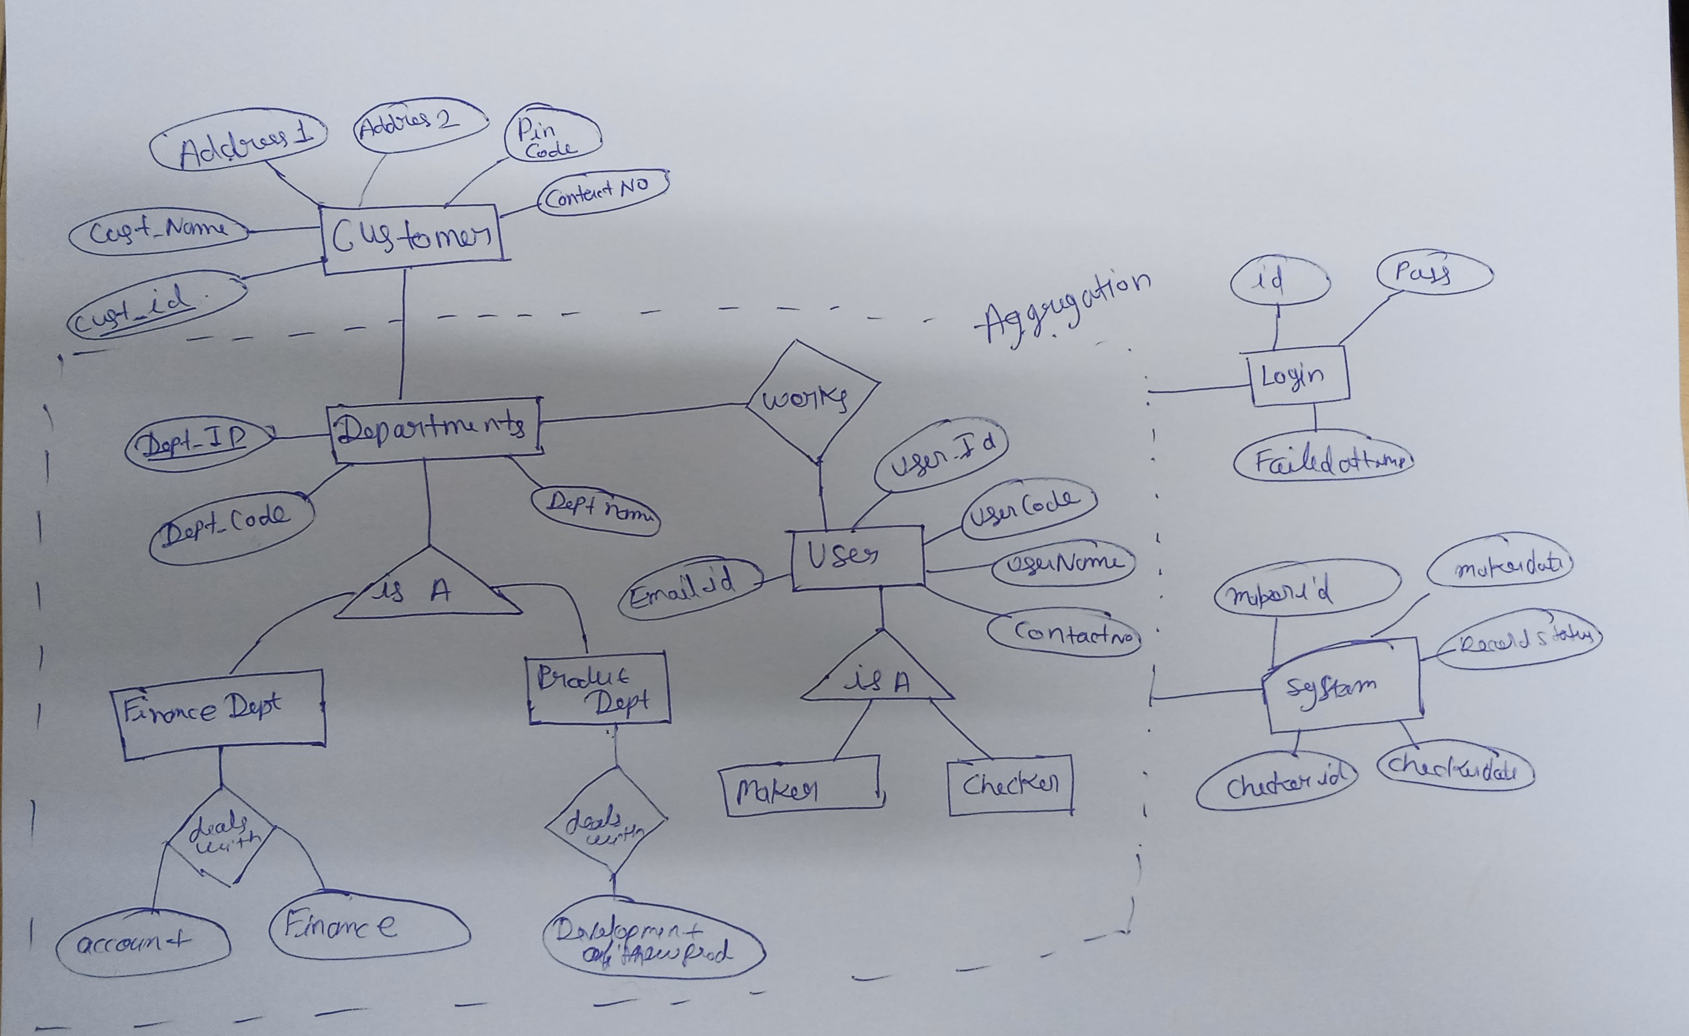
Relationship:-
1.BANK (1)-----Have------(N) CUSTOMERS
2. CUSTOMER---Consist-of-----(N)DEPARTMENTS
3. FINANCE-DEPT------IS-A---------DEPARTMENT
4. PRODUCT-DEPT--------IS-A-----------DEPARTMENT
5. FIANACE-DEPT ------DEALS-WITH -----FIANACE,ACCOUNTS
6. PRODUCT-DEPT-------DEALS-WITH------NEW-PRODUCT
7. USERS---------WORK-IN---------DEPARTMENTS
8. USER(M)-------IS-A----------(N) MAKER,CHECKER,MAKERCHECKER
9. MAKER/MAKER-CHECKER ------TASKS---------(N)ADDITION,MODIFICATION,DELETION,SEARCH-OF-RECORD
10.CHECKER(M)-------WORK AS -----(N)SEARCH,AUTHORIZED,REJECT-THE-RECORD
11. USER-----ACCESS-------SYSTEM
- Create tables (with appropriate data type and size of fields and constraints). SQL – Day 1
Ans:-
create table customer_abhishek_brd
( customer_id number primary key not null,
customer_name varchar2(50) not null,
cust_add varchar2(200),
cust_pin_Code number(6),
cust_phone_num number(10)not null,
contact_person_name varchar2(30),
reltn_mng_name varchar2(50),
max_trans_amunt number(8,2)
);

create table department_abhishek_brd
(
dept_id number(4) primary key,
dept_code varchar2(10),
dept_name varchar2(50)
);
create table fiance_dept_abhishek
(
id number primary key,
deptno number(4)
);
create table product_dept_abhishek_brd
(
id number primary key,
deptno number(4)
);
create table user_abhishek_brd
(
user_id number,
password varchar2(20),
user_code varchar2(50) primary key,
user_name varchar2(50),
user_contactno number(10),
user_email varchar2(50)
constraint email_check_abhishek
check(instr(user_email,'@google.com')>0)
);

alter table user_abhishek_brd add unique(user_id);

create table maker_abhishek_brd
(
maker_id number ,
maker_date date default sysdate
);
create table checker_abhishek_brd
(
checker_id number ,
checker_date date default sysdate
);
create table records_abhishek_brd
(
maker_id number,
maker_date date,
checker_id number,
checker_date date
);
create sequence auto_inc
start with 1;
create table login_process_abhishek_brd
(
user_id number ,
password varchar(20),
today_date varchar(20) default to_char(sysdate, 'Day'),
n_attempts number default auto_inc.nextval
);
alter table login_process_abhishek_brd add unique (n_attempts);
create table system_abhishek_brd
(
n_unsuccess_attempt number,
reject_level number,
file_loc varchar(100)
);
alter table system_abhishek_brd
add constraint att_fk_abhishek_brd
FOREIGN key(n_unsuccess_attempt)
references login_process_abhishek_brd(n_attempts);

alter table user_abhishek_brd
add constraint id_fk_abhishek_brd
FOREIGN key(user_id)
references customer_abhishek_brd(customer_id);
alter table fiance_dept_abhishek
add constraint fia_fk_abhishek_brd
foreign key (deptno)
references department_abhishek_brd(dept_id);
alter table product_dept_abhishek_brd
add constraint pro_fk_abhishek_brd
foreign key (deptno)
references department_abhishek_brd(dept_id);
alter table maker_abhishek_brd
add constraint mkr_fk_abhishek_brd
foreign key ( maker_id)
references user_abhishek_brd(user_id);
alter table checker_abhishek_brd
add constraint chr_fk_1abhishek_brd
foreign key (checker_id)
references user_abhishek_brd(user_id);
alter table login_process_abhishek_brd
add constraint lk_fkabhishek_brd
foreign key (user_id)
references user_abhishek_brd(user_id);
alter table records_abhishek_brd
add constraint mkk_fkk_abhishek_brd
foreign key (maker_id)
references maker_abhishek_brd(maker_id);
alter table records_abhishek_brd
add constraint ckk_fkk_abhishek_brd
foreign key (checker_id )
references checker_abhishek_brd(checker_id );

- Database setup scripts – the scripts should becreated in such a way complete database should be setup by calling a single parent script. - SQL – Day 1
Ans:-
insert into customer_abhishek_brd values (&customer_id
,'&customer_name','&address' ,&pin_cod , &phone_no ,
'&contact_person_name' , '&reltn_mng_name' , &max_transaction );
insert into department_abhishek_brd values (&department_id
,'&dept_code','&dept_name' );
insert into user_abhishek_brd values (&user_id ,'&password',' &user_code '
,'&user_name', &user_contactno , '&user_email' );
insert into system_abhishek_brd (file_loc) values ('&file_loc');
select * from customer_abhishek_brd

